Acknowledgement
The satisfaction that accompanies after the successful completion of any task will be incomplete without mentioning the people whose ceaseless and relentless cooperation, constant guidance and encouragement made this project possible.
We are grateful to our project supervisor Mr. Arpan Pokharel, our faculty teacher Mr. Ramesh Chalise, for the guidance, inspiration and constructive suggestions that helped us in the preparation of this project.
We are also appreciative among each other and have understood that teamwork, the designation of the task per the skillset one portrays, constant synchronization and monitoring of progress and instilling new knowledge and skill is imperative for the success of any given work.
Sincerely,
Prashant Tripathi
Miraj Puri
Sushant Adhikari

Declaration for
“Project Title”
Student’s Declaration

I (We) hereby declare that I (we) am (are) the only author(s) of this work and that no
sources other than the listed here have been used in this work.

Supervisor’s Declaration

I hereby recommend that this project entitled “Project Title” is done under my
supervision by Student Name1 and Student Name 2 during their _th Semester in
partial fulfilment of the requirements for the degree of Program Name under
Pokhara University is completed to my satisfaction and be processed for final
evaluation.

____________________________
Name of the Supervisor
Date:____ / ____ / ________

Letter of Approval

We certify that we have examined this report entitled “Project Title” and are satisfied
with the project defence. In our opinion it is satisfactory in the scope and qualify as
project in partial fulfilment of the requirements for the degree of Program Name
under Pokhara University.

_____________________
___
Supervisor
Arpan Pokhrel

_____________________
___
Examiner

Date:____ / ____ /

Contents
Declaration for 3
Supervisor’s Declaration 4
Letter of Approval 5
LIST OF FIGURES 7
1. Introduction 9
2. Objective 10
3. Problem statement 11
4. Background Study 12
5. System design 13
Use Case Diagram 13
6. Data Flow Diagram (DFD) 14
Level 0 (Context Diagram): 14
Level 1 (Detailed Decomposition): 15
System Flowchart 16

List of figures
Figure 1 use case diagram 13
Figure 2:DFD level 0 14
Figure 3:DFD level 1 15
Figure 4 flowchart 16

ABBREVIATIONS

Introduction
In recent years, managing and conducting democratic elections or organizational polling has become a major challenge due to rising administrative costs and the vulnerability of traditional paper-based methods. Most small-scale organizations, academic institutions, and local communities rely on manual voting procedures that are labor-intensive, time-consuming, and highly prone to human error. Without a secure and streamlined way to cast and tally ballots, many institutions struggle with delayed results, disputes over accuracy, and a general lack of trust in the electoral outcome.
While there are many enterprise-level digital voting platforms available, most are designed for large-scale government elections and are often too complex or expensive for an organization's daily polling needs. Many of these existing digital solutions are either locked behind costly corporate licensing fees or require complex network infrastructures to manage simple operations. Institutions need a simple, focused, and free tool that helps them conduct secure voting and aggregate data seamlessly without any extra cost.
To address these issues, we will develop "Matpatra" (or your preferred project name), a user-centric digital voting system application using the C programming language. The system will provide a practical, secure, and straightforward environment where administrators can register voters, create candidate lists, and allow users to cast their ballots digitally. By utilizing C programming and robust file-handling techniques, the system will securely store voting records locally, preventing unauthorized tampering and allowing real-time, automated vote calculation.
The main goal of this application is to promote transparency, efficiency, and integrity within localized voting processes. Through localized data storage and strict user authentication controls, the application will eliminate double-voting, minimize human errors in counting, and encourage higher democratic participation. By offering a reliable and cost-effective solution, this system will empower institutions to take control of their electoral processes efficiently and confidently.

Objective
- Automate and Streamline Vote Casting and Counting: To develop a user-friendly, terminal-based C interface that replaces slow manual record-keeping with an efficient digital system. This allows eligible voters to cast their ballots seamlessly while managing fluid databases of local candidates and voter registration details.
- Implement Real-Time, Secure Local Election Monitoring: To leverage local file-handling techniques in C for permanent, tamper-resistant data storage and instantaneous vote tallying without relying on complex, high-cost network setups or cloud utilities. This backend architecture ensures real-time vote consolidation while preventing critical issues like double-voting.
- Provide a High-Accessibility, Distraction-Free Electoral Tool: To deliver a completely cost-free and advertisement-free platform tailored specifically to small-scale community or institutional polling. By eliminating expensive subscription structures and data-privacy risks associated with free online forms, the application ensures a transparent and highly trusted environment for electoral management.
- Ensure Data Integrity and Prevent Fraudulent Polling: To implement validation rules and voter authentication checks within the C backend that prevent common voting discrepancies, such as duplicate voting or unregistered submissions. By structuring a clean, rule-bound logic, the application guarantees that each eligible user gets exactly one vote, preserving the democratic fairness of the election.

Problem statement
- Vulnerability of Manual Ballot Systems: Traditional paper-based voting methods are slow, labor-intensive, and highly prone to human error during counting. Additionally, physical ballots carry a significant risk of being lost, damaged, stolen, or intentionally destroyed.
- Absence of Systematic Audit Trails: Small-scale organizations or academic institutions often lack a secure, structured digital database to track voter participation. Without automated, real-time logging, it is difficult for administrators to verify voter credentials or provide a transparent audit trail in case of disputes.
- Risk of Fraudulent Activity and Double-Voting: Manual verification systems struggle to effectively prevent voter fraud, such as duplicate voting or ballot stuffing, especially when dealing with large or fluctuating voter lists.
- High Costs and Complexity of Existing Platforms: Most enterprise-level electronic voting systems available on the market are designed for large-scale governmental use, making them overly complex and financially unviable for local community, school, or organizational elections.

Background Study
The background of this project is rooted in the evolving democratic habits of students and the historical shift from manual ballot-counting to digital automation. In the past, student organizations traditionally relied on physical paper ballots and "ballot boxes" to conduct campus elections. Research shows these traditional systems are highly prone to physical hazards, ballot stuffing, theft, data loss, and human tallying errors. Furthermore, manual counting is inefficient and time-consuming.
With the rise of technology, digital voting tools like ElectionBuddy and OpaVote emerged to handle ballot logging and candidate categorization. However, many of these platforms were developed for corporate or national governance and are overly complex for simple student needs. Additionally, current findings indicate that existing free applications are heavily cluttered with advertisements or require expensive subscription models to unlock essential features like secure data backups and cryptographic auditing. This creates a significant barrier for student bodies operating on limited institutional budgets.
To address these limitations, we have chosen to implement [Project Name, e.g., Matpatra] as a localized, terminal-based C application. By utilizing the C programming language, we can develop a lightweight, efficient tool that functions entirely offline without the need for high-cost external servers or internet connectivity. This project removes distracting advertisements and subscription fees, providing a secure, structured, and budget-friendly environment that maintains absolute data integrity while encouraging campus democratic trust

System design

Use Case Diagram
The Use Case Diagram defines the behavioral boundaries of the application,
illustrating how the primary actor (the Student/User) triggers core operations without
detailing the background storage mechanics.

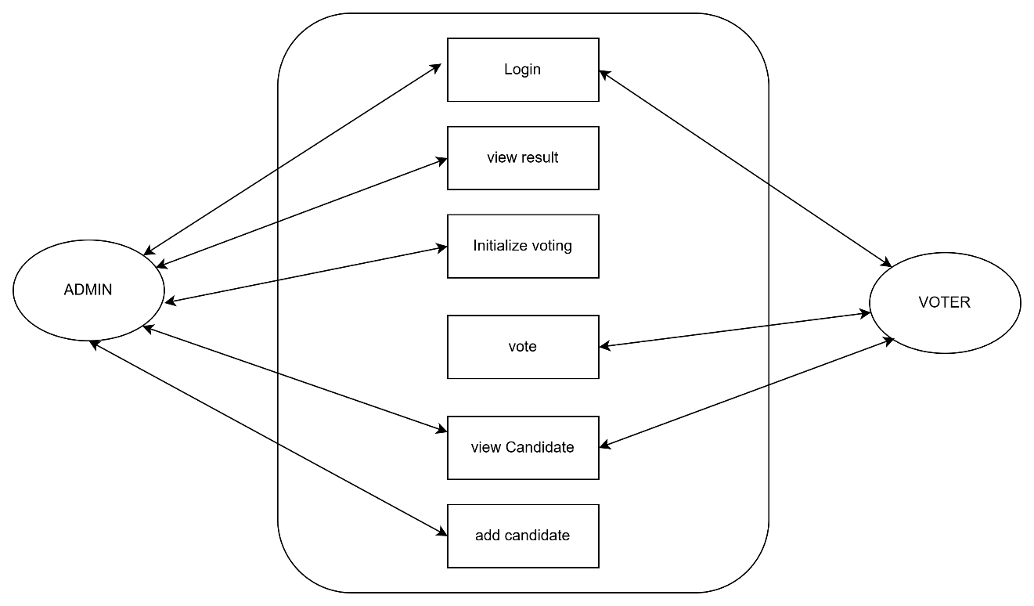
Figure 1 use case diagram

Data Flow Diagram (DFD)
The Data Flow Diagram represents the logical tracking of data through the program
structure, mapping how user inputs are processed and saved in the text logs (users.txt
and records.txt).
Level 0 (Context Diagram): Treats the entire system as a single process node,
illustrating the raw input-output boundary between the User and the application.

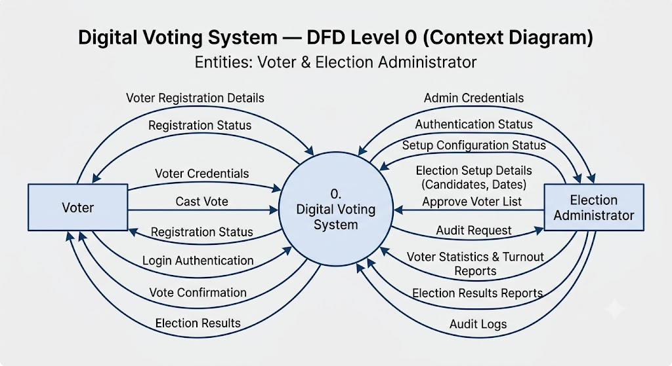
Figure 2:DFD level 0

Level 1 (Detailed Decomposition): Breaks down the central system process into
individual functional modules (signup, signing, add Record, etc.), showing exactly how
data reads from or appends to local storage via file handling.
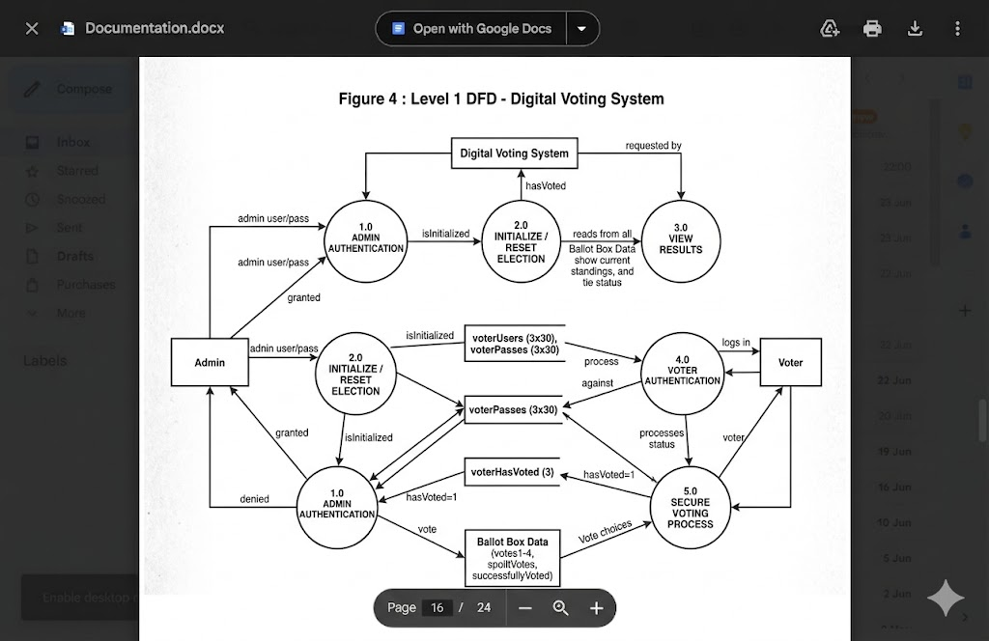
Figure 3:DFD level 1

System Flowchart
While the DFD tracks data streams, the System Flowchart diagrams the exact
chronological execution logic, sequence of algorithmic steps, and condition branching rules handled by the program at runtime.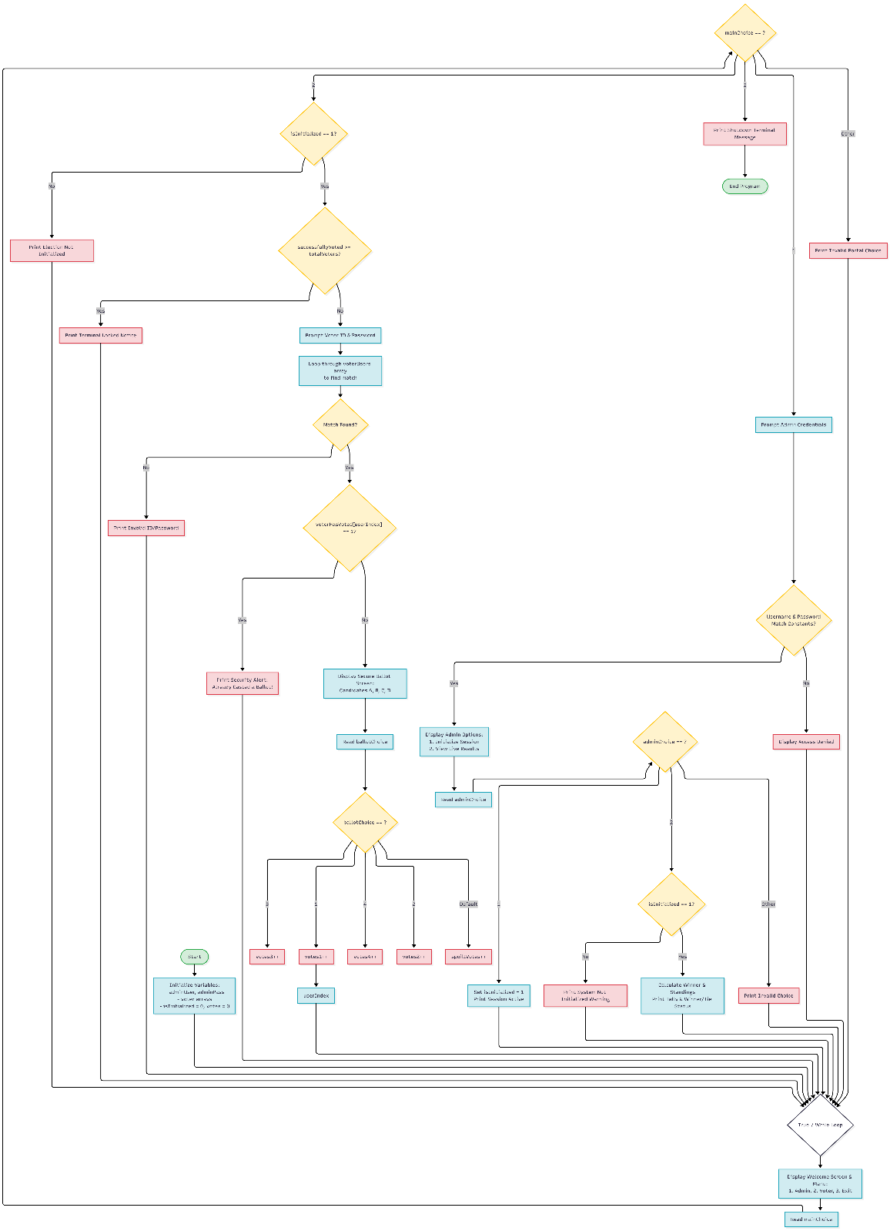
Figure 4 flowchart

Development
The development phase of the Digital Voting System involves a systematic approach to planning, organizing, and executing the technical aspects of the project. This section outlines the Software Development Life Cycle (SDLC) model adopted, the technical environment utilized, and the collaboration strategies employed to ensure the project meets its defined security, accuracy, and operational objectives.

Software Development Life Cycle (SDLC) – Prototype Model
For this project, we have implemented the Prototype Model as our primary development paradigm. This model is an iterative approach where a simplified version of the software is built, tested, and refined based on feedback before the final product is deployed. This is particularly suitable for the Digital Voting System because it allows us to visualize the user interface, ballot flow, and core cryptographic/verification logic early in the process, ensuring the final application is intuitive, secure, and meets voter needs. The phases include:
Requirement Gathering and Analysis: Defining the basic operational needs of the election process, such as voter authentication, ballot confidentiality, and real-time tally integrity.
Quick Design: Creating a preliminary design of the voting interface, ballot selection screens, and the secure file-handling/database structure for immutable data persistence.
Building Prototype: Developing a basic version of the web/desktop application with core functionalities like voter login, candidate selection, and secure ballot submission.
User Evaluation: Testing the prototype with a control group of voters and election auditors to ensure the submission logic is foolproof and the interface prevents accidental invalid votes.
Refining Prototype: Making critical security, accessibility, and performance updates based on testing results to ensure zero data leakage and optimal system uptime.
Final Product Development: Completing the full, end-to-end application based on the refined prototype, incorporating advanced encryption algorithms and robust administrative control panels.

Development Environment and Tools
To maintain absolute compliance with systemic architecture designs and strict security baselines, specific development, documentation, and scheduling platforms were selected based on stability and performance:
Primary IDE & Toolchain (VS Code / DEV C++ / Modern Web Stack): Selected for its extensible environment, allowing for precision line-by-line debugging of voter authentication modules, encryption protocols, and secure session management without heavy system overhead.
Documentation & Report Compilation (Microsoft Word / Google Docs): Used to maintain formal styling, version control, and team validation over technical specifications and compliance documentation.
System Design & Modelling Tools (Draw.io / diagrams.net): Used to construct high-fidelity Level 0 Context Diagrams, Level 1 Data Flow Diagrams, and Use Case Diagrams, ensuring the software logic mirrors the theoretical security models perfectly.
Project Scheduling (Gantt Chart Utilities): Leveraged to chart, track, and monitor chronological task dependencies, preventing scope creep and ensuring readiness before the evaluation and audit deadlines.

Collaboration and Communication Channels
Due to the critical technical requirements of collaborative security implementation and strict timeline synchronization, a unified communication stack was deployed:
Microsoft Teams: Utilized as the primary interface for formalized alignment meetings with the project supervisor and security auditors. This channel ensured structured milestone check-ins, architectural reviews, and rapid feedback loop adjustments.
WhatsApp Workspace Groups: Deployed for internal peer-to-peer developer coordination. This permitted instant, real-time code snippet debugging, error log sharing, and rapid synchronization of cryptographic sub-module tasks.
Finally, most importantly, the chart of work assignment.
S.N | Name of the member | Work assigned | Remarks
1 | Prashant Tripathi | - Gantt Chart  - Problem Identification  - Support in system design.
2 | Miraj Puri | - Support in system design.  - Feasibility analysis.
3 | Sushant Adhikari | - Designed Flowchart.  - Support in system design.  - Logic definition.

